Instructions for Making Skills Ratings

These questions are about work-related skills. A skill is the ability to perform a task well. It is usually developed over time through training or experience. A skill can be used to do work in many jobs or it can be used in learning. You will be asked about a series of different skills and how they relate to your current job—that is, the job you hold now.

Each skill in this questionnaire is named and defined.

For example:
Writing | Communicating effectively in writing as appropriate for the needs of the audience.
You are then asked two questions about each skill:
A

How important is the skill to the performance of your current job?

For example:

How important is WRITING to the performance of your current job?
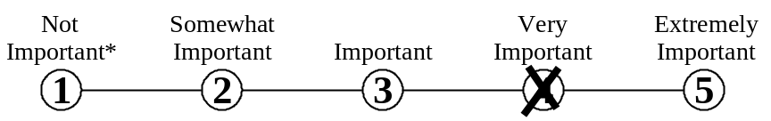

Mark your answer by putting an X through the number that represents your answer.
Do not mark on the line between the numbers.

*If you rate the skill as Not Important to the performance of your job, mark the one [ ] then skip over question B and proceed to the next skill.

B

What level of the skill is needed to perform your current job?

To help you understand what we mean by level, we provide you with examples of job-related activities at different levels. For example:

What level of WRITING skill is needed to perform your current job?
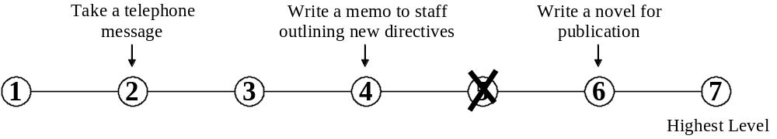

Mark your answer by putting an X through the number that represents your answer.
Do not mark on the line between the numbers.

- Reading Comprehension | Understanding written sentences and paragraphs in work-related documents.
A. How important is READING COMPREHENSION to the performance of your current job?
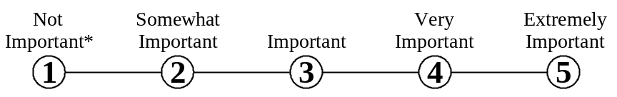

* If you marked Not Important, skip LEVEL below and go on to the next skill.

B. What level of READING COMPREHENSION is needed to perform your current job?
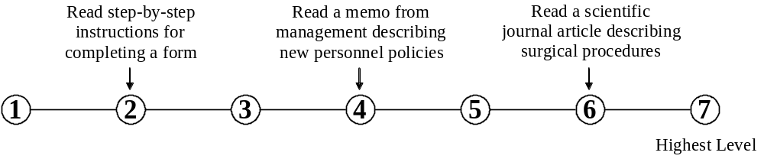

- Active Listening | Giving full attention to what other people are saying, taking time to understand the points being made, asking questions as appropriate, and not interrupting at inappropriate times.
A. How important is ACTIVE LISTENING to the performance of your current job?

* If you marked Not Important, skip LEVEL below and go on to the next skill.

B. What level of ACTIVE LISTENING is needed to perform your current job?
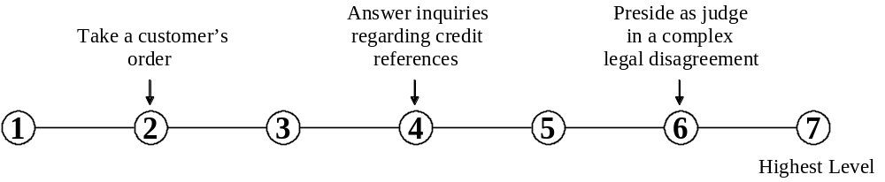

- Writing | Communicating effectively in writing as appropriate for the needs of the audience.
A. How important is WRITING to the performance of your current job?

* If you marked Not Important, skip LEVEL below and go on to the next skill.

B. What level of WRITING is needed to perform your current job?
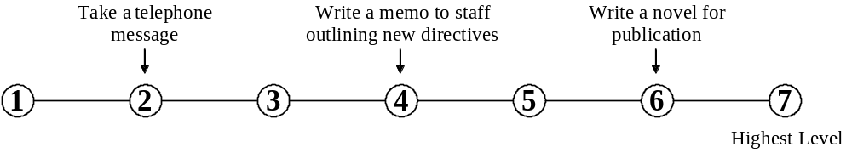

- Speaking | Talking to others to convey information effectively.
A. How important is SPEAKING to the performance of your current job?

* If you marked Not Important, skip LEVEL below and go on to the next skill.

B. What level of SPEAKING is needed to perform your current job?
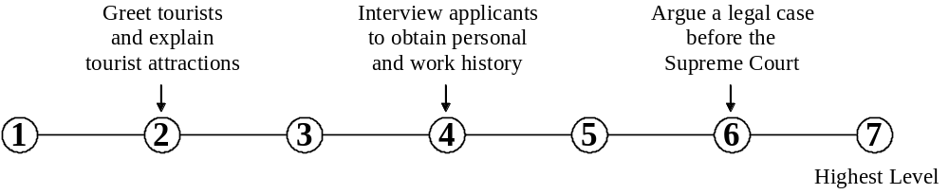

- Mathematics | Using mathematics to solve problems.
A. How important is MATHEMATICS to the performance of your current job?

* If you marked Not Important, skip LEVEL below and go on to the next skill.

B. What level of MATHEMATICS is needed to perform your current job?
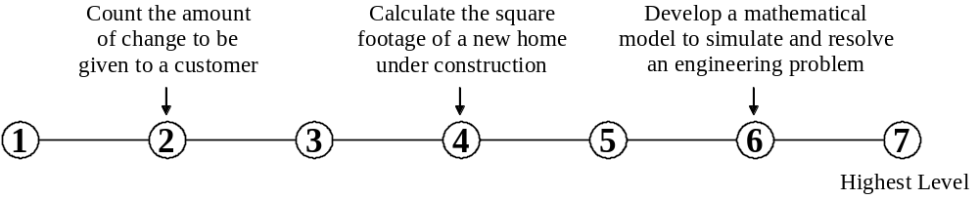

- Science | Using scientific rules and methods to solve problems.
A. How important is SCIENCE to the performance of your current job?

* If you marked Not Important, skip LEVEL below and go on to the next skill.

B. What level of SCIENCE is needed to perform your current job?
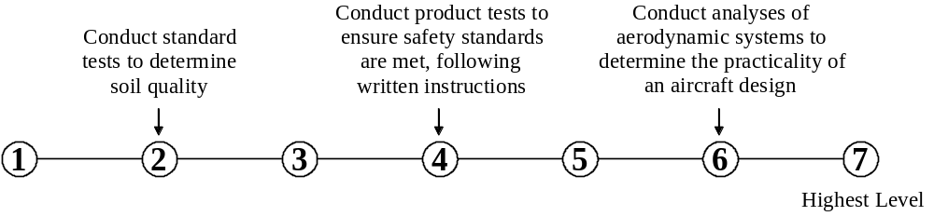

- Critical Thinking | Using logic and reasoning to identify the strengths and weaknesses of alternative solutions, conclusions, or approaches to problems.
A. How important is CRITICAL THINKING to the performance of your current job?

* If you marked Not Important, skip LEVEL below and go on to the next skill.

B. What level of CRITICAL THINKING is needed to perform your current job?
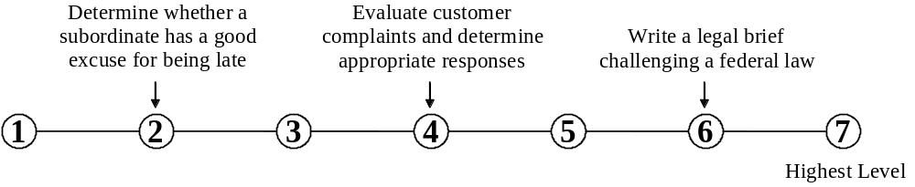

- Active Learning | Understanding the implications of new information for both current and future problem-solving and decision-making.
A. How important is ACTIVE LEARNING to the performance of your current job?

* If you marked Not Important, skip LEVEL below and go on to the next skill.

B. What level of ACTIVE LEARNING is needed to perform your current job?
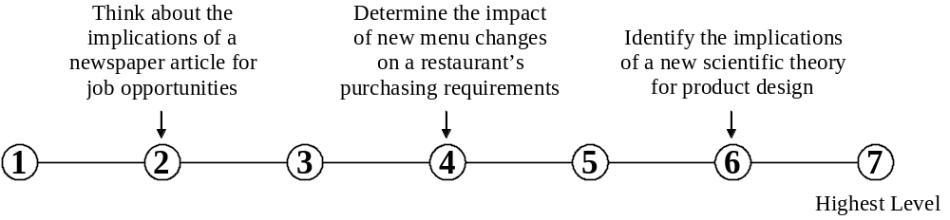

- Learning Strategies | Selecting and using training/instructional methods and procedures appropriate for the situation when learning or teaching new things.
A. How important are LEARNING STRATEGIES to the performance of your current job?

* If you marked Not Important, skip LEVEL below and go on to the next skill.

B. What level of LEARNING STRATEGIES is needed to perform your current job?
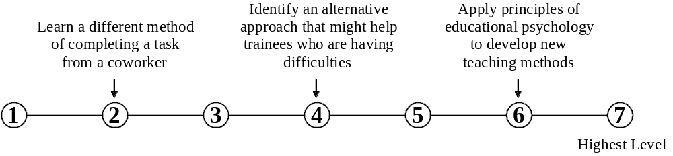

- Monitoring | Monitoring/assessing performance of yourself, other individuals, or organizations to make improvements or take corrective action.
A. How important is MONITORING to the performance of your current job?

* If you marked Not Important, skip LEVEL below and go on to the next skill.

B. What level of MONITORING is needed to perform your current job?

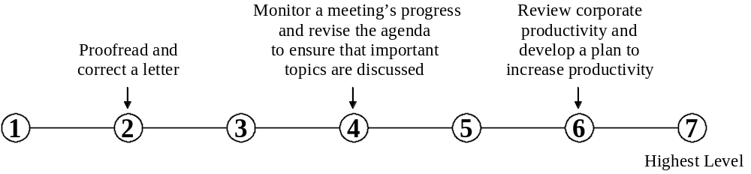

- Social Perceptiveness | Being aware of others’ reactions and understanding why they react as they do.
A. How important is SOCIAL PERCEPTIVENESS to the performance of your current job?

* If you marked Not Important, skip LEVEL below and go on to the next skill.

B. What level of SOCIAL PERCEPTIVENESS is needed to perform your current job?
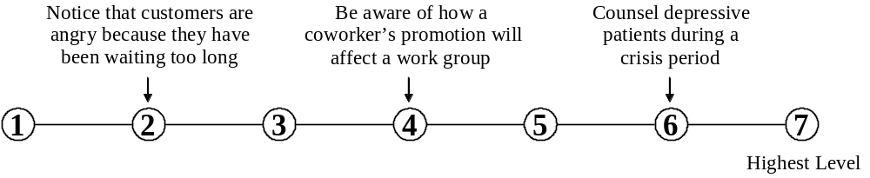

- Coordination | Adjusting actions in relation to others’ actions.
A. How important is COORDINATION to the performance of your current job?

* If you marked Not Important, skip LEVEL below and go on to the next skill.

B. What level of COORDINATION is needed to perform your current job?
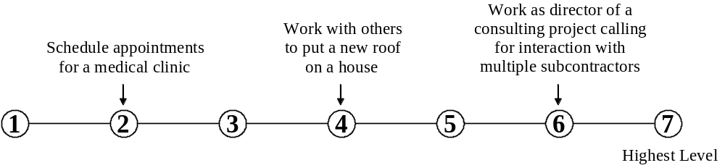

- Persuasion | Persuading others to change their minds or behavior.
A. How important is PERSUASION to the performance of your current job?

* If you marked Not Important, skip LEVEL below and go on to the next skill.

B. What level of PERSUASION is needed to perform your current job?
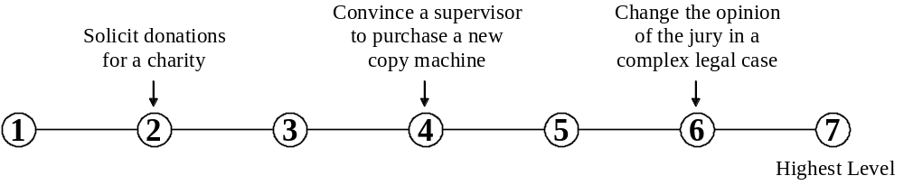

- Negotiation | Bringing others together and trying to reconcile differences.
A. How important is NEGOTIATION to the performance of your current job?

* If you marked Not Important, skip LEVEL below and go on to the next skill.

B. What level of NEGOTIATION is needed to perform your current job?
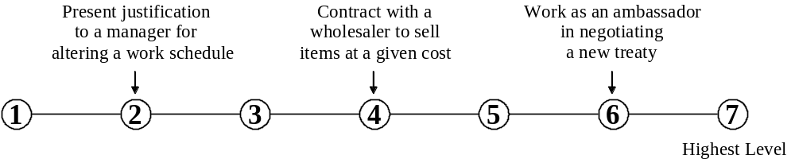

- Instructing | Teaching others how to do something.
A. How important is INSTRUCTING to the performance of your current job?

* If you marked Not Important, skip LEVEL below and go on to the next skill.

B. What level of INSTRUCTING is needed to perform your current job?
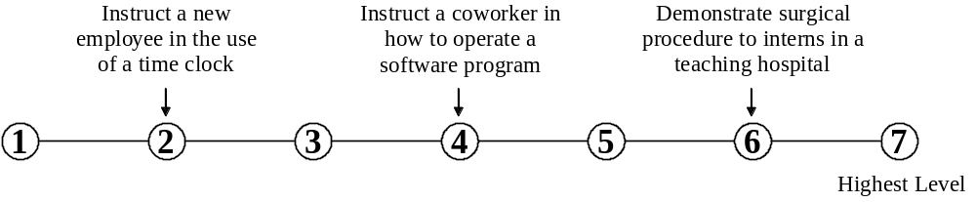

- Service Orientation | Actively looking for ways to help people.
A. How important is SERVICE ORIENTATION to the performance of your current job?

* If you marked Not Important, skip LEVEL below and go on to the next skill.

B. What level of SERVICE ORIENTATION is needed to perform your current job?
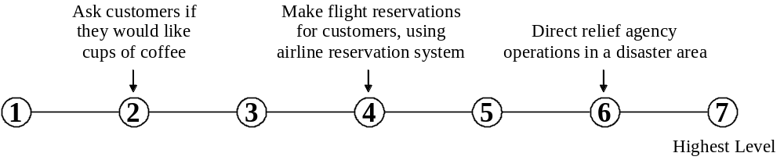

- Complex Problem Solving | Identifying complex problems and reviewing related information to develop and evaluate options and implement solutions.
A. How important is COMPLEX PROBLEM SOLVING to the performance of your current job?

* If you marked Not Important, skip LEVEL below and go on to the next skill.

B. What level of COMPLEX PROBLEM SOLVING is needed to perform your current job?
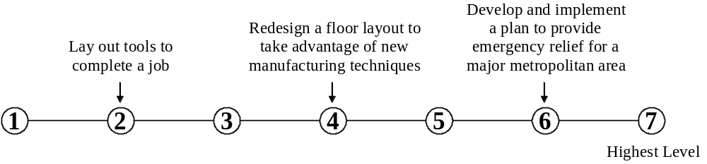

- Operations Analysis | Analyzing needs and product requirements to create a design.
A. How important is OPERATIONS ANALYSIS to the performance of your current job?

* If you marked Not Important, skip LEVEL below and go on to the next skill.

B. What level of OPERATIONS ANALYSIS is needed to perform your current job?
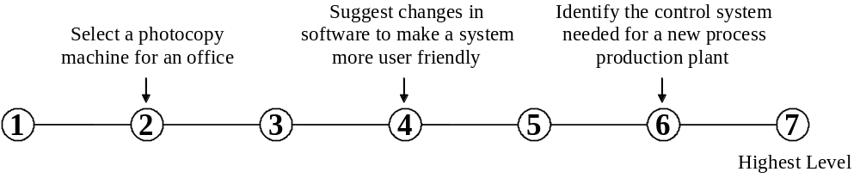

19. Technology Design | Generating or adapting equipment and technology to serve user needs.
A. How important is TECHNOLOGY DESIGN to the performance of your current job?

* If you marked Not Important, skip LEVEL below and go on to the next skill.

B. What level of TECHNOLOGY DESIGN is needed to perform your current job?
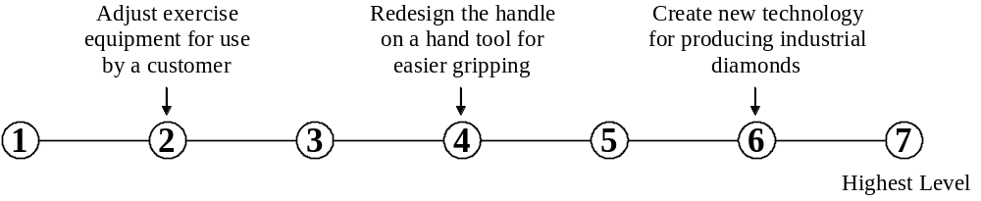

20. Equipment Selection | Determining the kind of tools and equipment needed to do a job.
A. How important is EQUIPMENT SELECTION to the performance of your current job?

* If you marked Not Important, skip LEVEL below and go on to the next skill.

B. What level of EQUIPMENT SELECTION is needed to perform your current job?
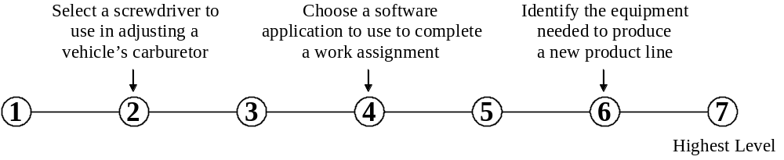

21. Installation | Installing equipment, machines, wiring, or programs to meet specifications
A. How important is INSTALLATION to the performance of your current job?

* If you marked Not Important, skip LEVEL below and go on to the next skill.

B. What level of INSTALLATION is needed to perform your current job?
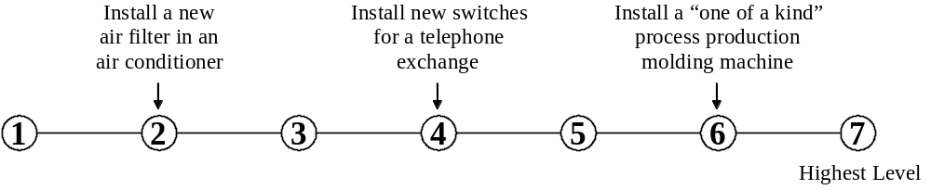

22. Programming | Writing computer programs for various purposes.
A. How important is PROGRAMMING to the performance of your current job?

* If you marked Not Important, skip LEVEL below and go on to the next skill.

B. What level of PROGRAMMING is needed to perform your current job?
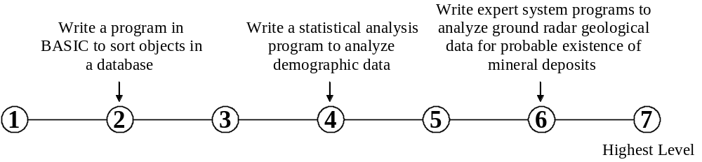

23. Quality Control Analysis | Conducting tests and inspections of products, services, or processes to evaluate quality or performance.
A. How important is QUALITY CONTROL ANALYSIS to the performance of your current job?

* If you marked Not Important, skip LEVEL below and go on to the next skill.

B. What level of QUALITY CONTROL ANALYSIS is needed to perform your current job?
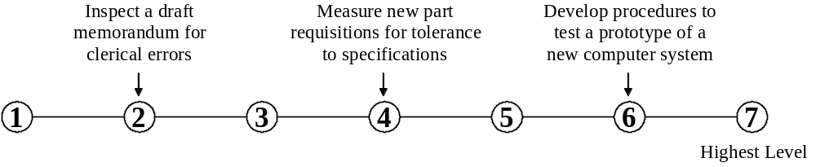

24. Operations Monitoring | Watching gauges, dials, or other indicators to make sure a machine is working properly.
A. How important is OPERATIONS MONITORING to the performance of your current job?

* If you marked Not Important, skip LEVEL below and go on to the next skill.

B. What level of OPERATIONS MONITORING is needed to perform your current job?

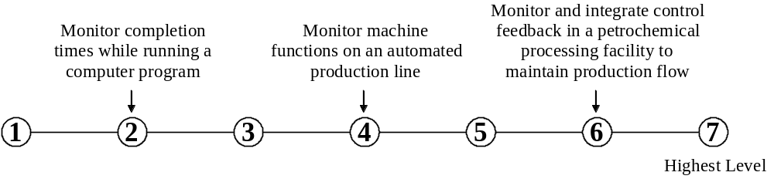

25. Operation and Control | Controlling operations of equipment or systems.
A. How important is OPERATION AND CONTROL to the performance of your current job?

* If you marked Not Important, skip LEVEL below and go on to the next skill.

B. What level of OPERATION AND CONTROL is needed to perform your current job?
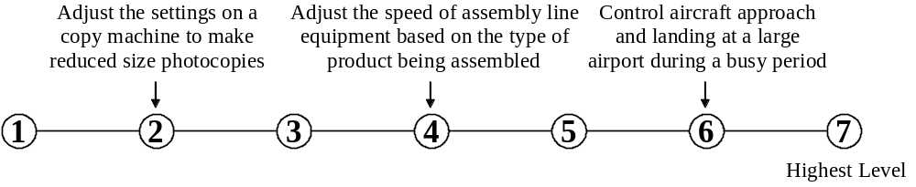

26. Equipment Maintenance | Performing routine maintenance on equipment and determining when and what kind of maintenance is needed.
A. How important is EQUIPMENT MAINTENANCE to the performance of your current job?

* If you marked Not Important, skip LEVEL below and go on to the next skill.

B. What level of EQUIPMENT MAINTENANCE is needed to perform your current job?

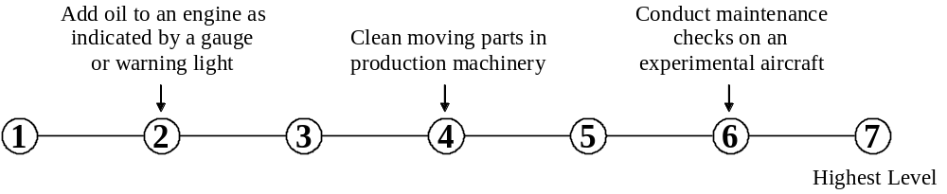

27. Troubleshooting | Determining causes of operating errors and deciding what to do about it.
A. How important is TROUBLESHOOTING to the performance of your current job?

* If you marked Not Important, skip LEVEL below and go on to the next skill.

B. What level of TROUBLESHOOTING is needed to perform your current job?
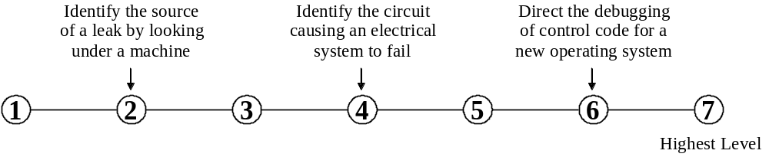

28. Repairing | Repairing machines or systems using the needed tools.
A. How important is REPAIRING to the performance of your current job?

* If you marked Not Important, skip LEVEL below and go on to the next skill.

B. What level of REPAIRING is needed to perform your current job?
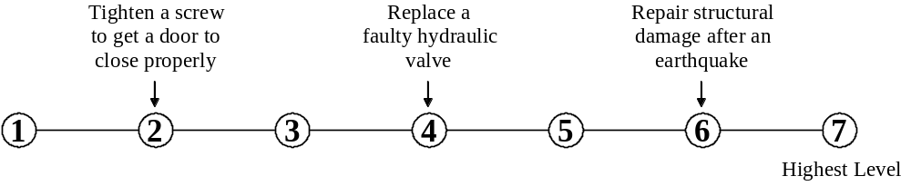

29. Systems Analysis | Determining how a system should work and how changes in conditions, operations, and the environment will affect outcomes.
A. How important is SYSTEMS ANALYSIS to the performance of your current job?

* If you marked Not Important, skip LEVEL below and go on to the next skill.

B. What level of SYSTEMS ANALYSIS is needed to perform your current job?
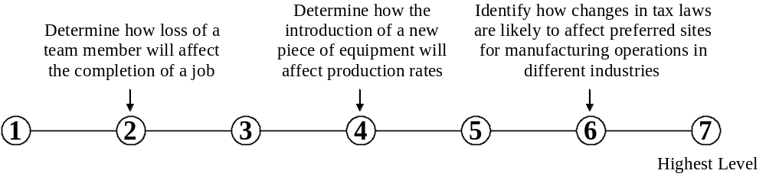

30. Systems Evaluation | Identifying measures or indicators of system performance and the actions needed to improve or correct performance, relative to the goals of the system.
A. How important is SYSTEMS EVALUATION to the performance of your current job?

* If you marked Not Important, skip LEVEL below and go on to the next skill.

B. What level of SYSTEMS EVALUATION is needed to perform your current job?
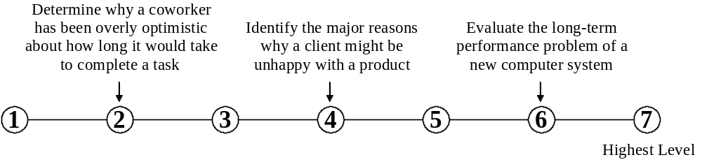

31. Judgment and Decision Making | Considering the relative costs and benefits of potential actions to choose the most appropriate one.
A. How important is JUDGMENT AND DECISION MAKING to the performance of your current job?

* If you marked Not Important, skip LEVEL below and go on to the next skill.

B. What level of JUDGMENT AND DECISION MAKING is needed to perform your current job?
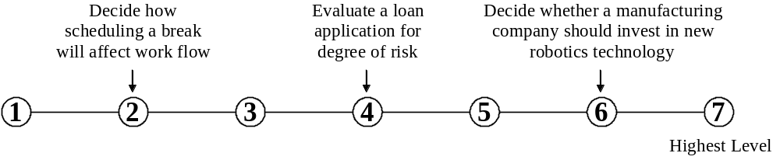

32. Time Management | Managing one’s own time and the time of others.
A. How important is TIME MANAGEMENT to the performance of your current job?

* If you marked Not Important, skip LEVEL below and go on to the next skill.

B. What level of TIME MANAGEMENT is needed to perform your current job?

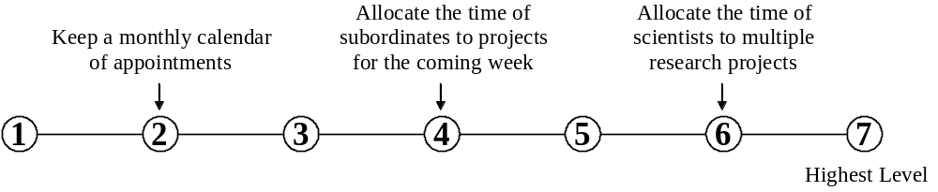

33. Management of Financial Resources | Determining how money will be spent to get the work done, and accounting for these expenditures.
A. How important is MANAGEMENT OF FINANCIAL RESOURCES to the performance of your current job?

* If you marked Not Important, skip LEVEL below and go on to the next skill.

B. What level of MANAGEMENT OF FINANCIAL RESOURCES is needed to perform your current job?
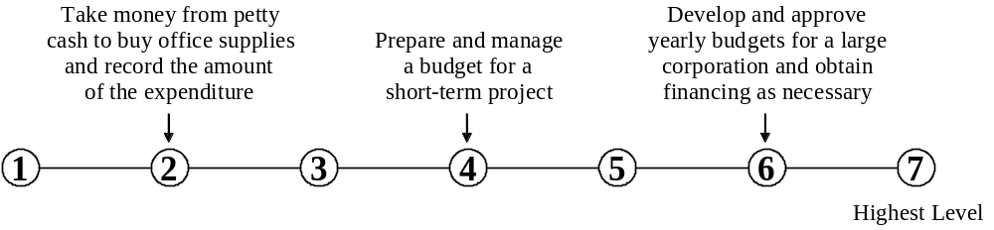

34. Management of Material Resources | Obtaining and seeing to the appropriate use of equipment, facilities, and materials needed to do certain work.
A. How important is MANAGEMENT OF MATERIAL RESOURCES to the performance of your current job?

* If you marked Not Important, skip LEVEL below and go on to the next skill.

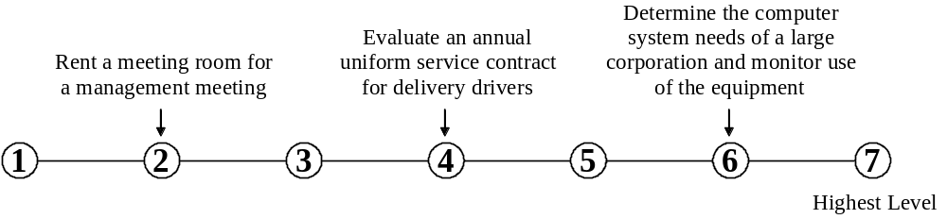B. What level of MANAGEMENT OF MATERIAL RESOURCES is needed to perform your current job?

35. Management of Personnel Resources | Motivating, developing, and directing people as they work, identifying the best people for the job.
A. How important is MANAGEMENT OF PERSONNEL RESOURCES to the performance of your current job?

* If you marked Not Important, skip LEVEL below and go on to the next skill.

B. What level of MANAGEMENT OF PERSONNEL RESOURCES is needed to perform your current job?
